Lab 1 Report – Survey of Machine Tools for Selected Cutting Processes
Stanisław Kotowicz 257100
Business, Society and Technology
IFE, 3rd semester

LAB REPORT
MANUFACTURING
Lab no. 1
Title: Survey of machine tools for selected cutting processes

Date of lab: 09/10/2025
Contents
1. The Universal Lathe 2
Structure of the Lathe 2
Kinematics and Movements 4
Shaped Surfaces and Involved Elements 5
Fixing and Clamping Methods 7
Tools and Mounting 8
Special Equipment and Lathe Types 11
2. Drilling and Milling Machines 12
A. Drilling Machines 12
Structure and Construction 12
Kinematics and Movements 15
Shaped Surfaces and Involved Elements 16
Fixing and Clamping Methods 17
Tools and Mounting 19
Special Equipment and Drilling Machine Types 21
B. Milling Machines 22
Structure and Construction 22
Kinematics and Movements 25
Shaped Surfaces and Involved Elements 25
Fixing and Clamping Methods 26
Tools and Mounting 28
Special Equipment and Milling Machine Types 30
Conclusions 31

1. The Universal Lathe

Structure of the Lathe
The construction of a universal lathe is founded upon a rigid bed, typically cast from iron to dampen vibrations, which supports all other functional components. The headstock is permanently fixed to the left side of the bed and houses the main spindle along with the speed change gearbox, which transmits rotational torque from the electric motor to the workpiece. Opposite the headstock lies the tailstock, a movable unit that slides along the bed's guideways; it is primarily used to support long workpieces using a center or to hold axial tools such as drill bits. Between these two elements operates the carriage assembly, which moves longitudinally along the bed. The carriage supports the cross slide for transverse motion and the compound rest, which holds the tool post. The movement of the carriage is driven by the feed rod for standard turning operations or the lead screw for thread-cutting operations, ensuring precise kinematic synchronization.
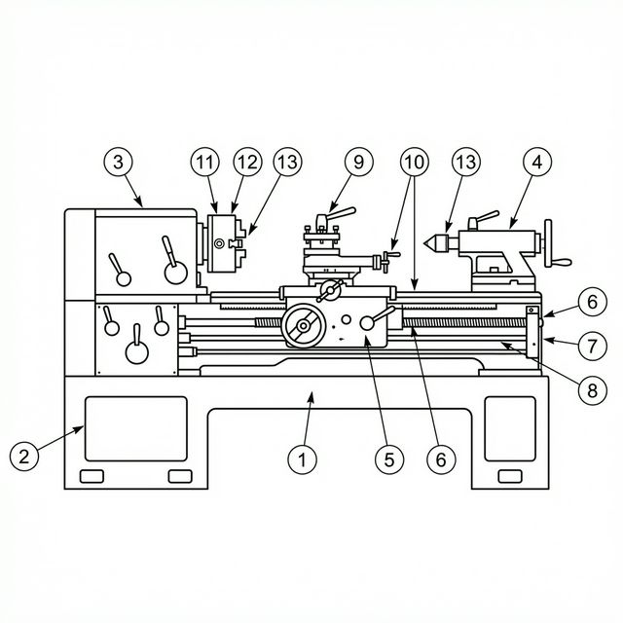
Figure 1. Basic lathe structure with the main components marked.
1. Bed
2. Left leg (with engine inside)
3. Headstock
4. Tailstock
5. Cross slide
6. Carriage
7. Feed rod
8. Lead screw
9. Tool post
10. Guideways
11. Spindle
12. Jaw chuck
13. Center

Kinematics and Movements
The kinematic system of a lathe is distinct in that the main cutting movement is rotary and is performed by the workpiece itself. This rotational motion is generated by the spindle in the headstock. Simultaneously, the cutting tool performs the feed movement, which is typically a linear translation. The tool moves longitudinally along the bed to reduce the diameter of the workpiece (turning) or transversely across the axis of rotation to generate a flat surface (facing). The depth of cut is determined by the position of the tool perpendicular to the surface being machined. The combination of the workpiece's rotation and the tool's linear feed results in the helical path of the cutting edge relative to the workpiece surface.
The spindle speed (n, in RPM) is selected according to the recommended cutting speed (V_{c}) for the workpiece material and the diameter (d) being machined, using the formula: n = (1000 × V_{c}) / (π × d). The feed rate (f, in mm/rev) determines the surface finish quality — lower feeds produce smoother finishes. The depth of cut (a_{p}, in mm) governs the amount of material removed per pass and is set by advancing the cross slide. These three parameters — cutting speed, feed, and depth of cut — form the fundamental cutting regime for all lathe operations.
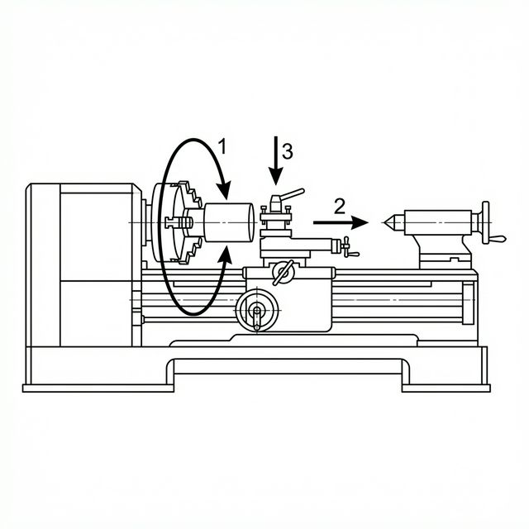
Figure 2. Kinematics and types of movements on a lathe, showing the main rotary motion of the workpiece and the linear feed of the tool.

Shaped Surfaces and Involved Elements
Lathes are fundamentally designed to generate surfaces of revolution. The most common operation is longitudinal turning, which creates external cylindrical surfaces. By modifying the tool's trajectory or using formed tools, the machine can also produce conical surfaces, spherical profiles, and varying grooves. Internal machining operations, such as boring, extend these capabilities to the interior of the workpiece, creating cylindrical or conical holes. Additionally, the lathe is capable of facing operations where the tool moves perpendicular to the rotation axis to create a flat plane on the end of the bar. Thread cutting is another critical function, achieved by synchronizing the rotation of the spindle with the longitudinal feed of the tool via the lead screw to cut a helical groove. In all these processes, the headstock rotates the work while the carriage and cross slide dictate the profile geometry.
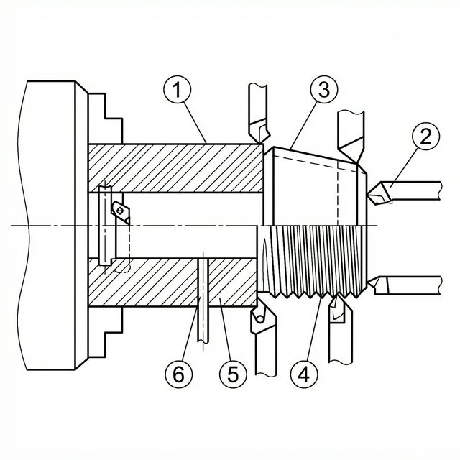
Figure 3. Typical shapes and surfaces produced on a lathe.
1. External cylindrical turning
2. Face turning (flat end)
3. Conical/taper turning
4. Threading
5. Grooving/parting
6. Boring (internal)

Fixing and Clamping Methods
The method of fixing the workpiece depends heavily on the geometry and length of the material. Several standard methods are used on lathes:
- Three-jaw self-centering chuck — the most common clamping device, mounted on the spindle nose. All three jaws move simultaneously via a scroll plate, automatically centering cylindrical and hexagonal workpieces. It allows for rapid setup and is ideal for short, regular-shaped parts.
- Four-jaw independent chuck — each jaw can be adjusted individually, allowing precise centering of irregular or non-cylindrical parts (square, rectangular, or eccentric shapes). Although setup is slower, it provides greater flexibility and accuracy than the three-jaw chuck.
- Between centers — used for long workpieces that are prone to deflection. A live center is inserted into the headstock spindle and a dead (or rotating) center into the tailstock. The torque is transmitted to the workpiece via a driving dog (lathe dog) clamped to the part. This method ensures the highest concentricity and is used when the part must be removed and re-mounted with guaranteed alignment.
- Collet chuck — a precision clamping device for small-diameter bar stock. A collet is a slotted sleeve that contracts around the workpiece when drawn into a tapered socket. Collets provide excellent concentricity and gripping force but are sized for specific diameters.
- Faceplate — a flat disc mounted on the spindle, used for clamping irregularly shaped workpieces using T-bolts and clamps. The workpiece is bolted directly to the faceplate surface and balanced with counterweights if necessary.
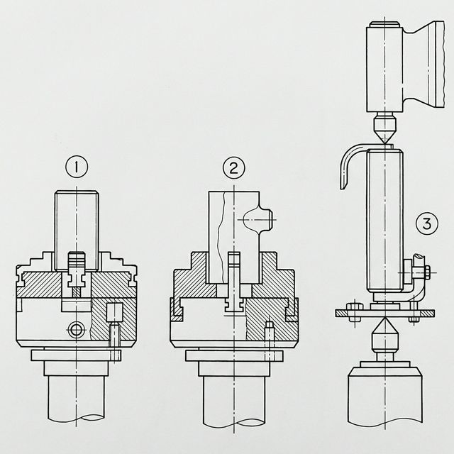
Figure 4. Different methods of fixing and clamping workpieces on a lathe.
1. Three-jaw self-centering chuck
2. Four-jaw independent chuck
3. Workpiece mounted between centers with driving dog
4. Live center (in headstock)
5. Dead center (in tailstock)

Tools and Mounting
The primary cutting instruments used on a lathe are single-point cutting tools. These tools consist of a shank (body) and a cutting tip, which may be made of high-speed steel (HSS), brazed cemented carbide, or — most commonly in modern practice — indexable carbide inserts clamped mechanically to a tool holder. The tool geometry (rake angle, clearance angle, nose radius) is selected based on the workpiece material and the type of operation.
Tools are securely mounted in the tool post, which sits atop the compound rest on the carriage. The tool post allows for height adjustment (the tool tip must be aligned with the spindle centerline) and angular positioning. Different types of tools commonly used on a lathe include:
- Roughing tools — with a large nose radius and strong geometry, designed for rapid material removal at high feed rates.
- Finishing tools — with a fine edge geometry and large nose radius, designed to produce smooth surface finishes at low feed rates.
- Threading tools — ground to the precise profile of the thread form (e.g., 60° for metric threads).
- Parting/grooving tools — narrow, blade-like tools for cutting grooves or parting off (separating) the finished part from the bar stock.
- Boring bars — long, slender tools with a single cutting point at the end, used for enlarging or finishing internal holes. They are mounted on the tool post or in a special boring bar holder.
Axial tools such as twist drills, reamers, and taps are not mounted on the carriage but are installed in the tailstock quill, typically via a Morse taper connection or a drill chuck. The spindle provides rotation while the tailstock quill provides the axial feed for these operations.
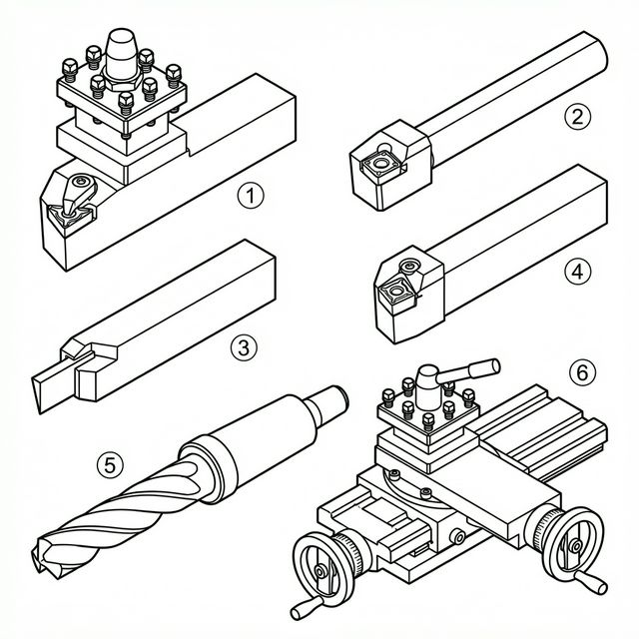
Figure 5. The most important tools used on a lathe and their mounting locations.
1. Turning tool (shank with carbide insert) in tool post
2. Boring bar
3. Parting/grooving tool
4. Threading tool
5. Twist drill in tailstock chuck (Morse taper)
6. Tool post on compound rest

Special Equipment and Lathe Types
To enhance productivity and versatility, standard lathes can be fitted with special equipment:
- Steady rest and follow rest — support devices for long, slender shafts to prevent bending and vibration during machining. The steady rest is fixed to the bed, while the follow rest is mounted on the carriage and moves with the tool, providing continuous support near the cutting point.
- Taper turning attachment — a device that guides the cross slide at a specific angle relative to the bed, allowing the machining of conical (tapered) surfaces without offsetting the tailstock.
- Thread-chasing dial — an indicator on the carriage that shows when to engage the half-nut for successive thread-cutting passes, ensuring the tool re-enters the same helical groove each time.
Several specialized types of lathes exist for specific industrial applications:
- Turret lathe — replaces the standard tailstock with a hexagonal (or square) turret that can hold up to six different tools. The turret indexes automatically to the next tool position after each operation, allowing rapid sequential operations (drilling, reaming, boring, tapping) without manual tool changes. Used in batch production.
- Carousel (Vertical) lathe — the faceplate rotates on a vertical axis rather than a horizontal one. This configuration simplifies the loading and clamping of very large, heavy, disc-shaped workpieces (such as flywheels, large flanges, and turbine casings), since gravity assists in seating the part.
- Multi-spindle automatic lathe — features 4, 6, or 8 spindles arranged in a circle. Several workpieces are machined simultaneously, each at a different stage of completion. After one cycle, the spindle carrier indexes and each workpiece advances to the next operation. Used in mass production of small parts from bar stock (screws, fittings, pins).
- CNC lathe — a computer numerically controlled lathe where all axis movements, spindle speeds, and feeds are programmed. CNC lathes with live tooling and a C-axis can perform milling, drilling, and tapping operations in addition to turning, eliminating the need for a second setup on a milling machine.
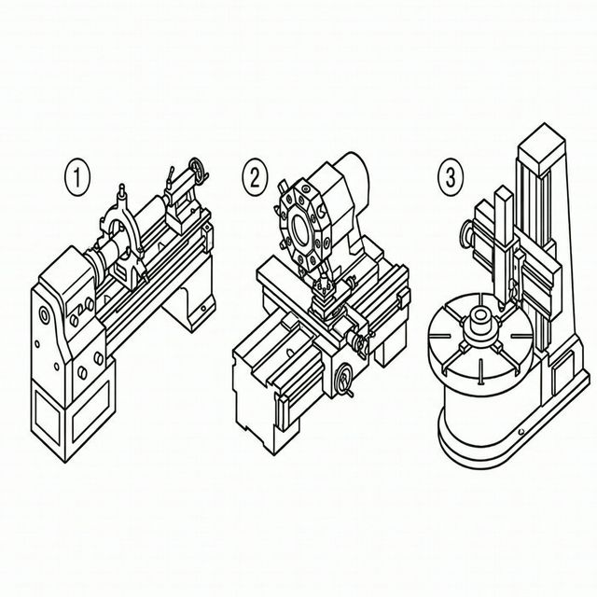
Figure 6. Special equipment and types of lathes: steady rest, turret lathe, and vertical (carousel) lathe.

2. Drilling and Milling Machines

A. Drilling Machines

Structure and Construction
The bench or column drilling machine (drill press) is one of the most fundamental machine tools found in any workshop. Its construction is organized around a robust vertical column, typically made of cast iron, which connects the heavy base at the bottom to the headstock at the top. The base serves as a stable foundation and often features T-slots or bolt holes for securing large workpieces or fixtures directly.
The headstock houses the electric motor, the V-belt or gear drive transmission, and the spindle mechanism. The spindle is a hollow, rotating shaft that receives the cutting tool. It can be advanced vertically downward toward the workpiece by means of a hand-operated lever (quill feed) or, on larger machines, an automatic power feed mechanism. The quill is spring-loaded to return to its upper position when the lever is released.
Between the base and the headstock, the work table is mounted on the column and can be adjusted vertically by loosening a clamp and sliding it to the required height. The table surface is typically flat and machined with T-slots for clamping vices, jigs, or fixtures. On some models, the table can also be tilted for angular drilling operations. A depth stop is provided on the quill to control the depth of the drilled hole precisely, and a graduated scale on the quill allows the operator to monitor the feed depth.
A key characteristic of the standard column drill press is that the workpiece must be positioned manually beneath the spindle, since neither the table nor the spindle head can be moved horizontally. This distinguishes it from the radial drilling machine, where the spindle can be repositioned.
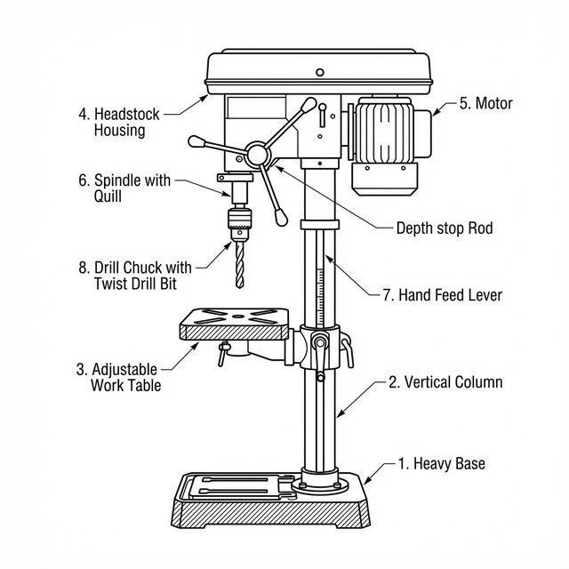
Figure 7. Structure of a column drilling machine (bench drill press).
1. Column
2. Base (with T-slots)
3. Work table
4. Headstock (housing motor and drive)
5. Spindle and quill
6. Hand feed lever
7. Depth stop
8. Drill chuck with drill bit

Kinematics and Movements
The kinematic system of a drilling machine is fundamentally different from that of a lathe. In a drilling machine, the cutting tool performs both of the primary movements. The drill bit executes the main rotary cutting motion (rotation around its own axis), and simultaneously performs the linear feed motion (axial advancement downward into the material). The workpiece remains completely stationary throughout the entire process, being clamped rigidly to the table or held in a vice.
This kinematic arrangement — where the tool provides both rotation and feed — differs significantly from the lathe, where the workpiece rotates and the tool feeds, and from the milling machine, where the tool rotates but the workpiece provides the feed motion. The rotational speed of the spindle (measured in revolutions per minute, RPM) and the feed rate (measured in millimeters per revolution, mm/rev) are the two primary cutting parameters.
The spindle speed is selected based on the cutting speed formula: n = (1000 × V_{c}) / (π × d), where V_{c} is the recommended cutting speed for the workpiece material and d is the drill diameter. The feed rate is chosen depending on the drill size, material hardness, and required hole quality. Excessive feed can lead to drill breakage due to high thrust forces, while too low a feed causes rubbing and work hardening rather than effective cutting. When drilling deep holes, a technique called "peck drilling" is used — the drill is periodically retracted from the hole to clear chips and allow coolant to reach the cutting zone, preventing chip jamming and overheating.
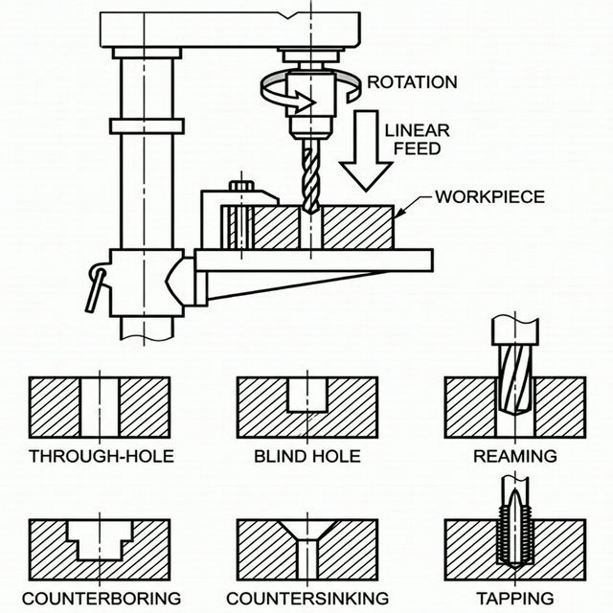
Figure 8. Kinematics of drilling (main rotary motion + axial feed by tool) and types of drilling operations.

Shaped Surfaces and Involved Elements
Drilling machines are primarily designed to produce cylindrical holes of various diameters and depths. However, the range of machinable surfaces extends well beyond simple through-holes. The main operations and the surfaces they create are:
- Drilling — creates cylindrical through-holes (passing completely through the workpiece) or blind holes (stopping at a controlled depth). The hole surface is produced by the two cutting lips (edges) of the twist drill.
- Reaming — a finishing operation that uses a multi-fluted reamer to improve the dimensional accuracy, roundness, and surface finish of a previously drilled hole. Reaming typically removes only 0.1–0.3 mm of material per side and produces tolerances of IT7 or better. The resulting surface is much smoother than a drilled hole.
- Counterboring — creates a flat-bottomed cylindrical recess at the top of an existing hole to accommodate the head of a socket-head cap screw or bolt, allowing it to sit flush with or below the workpiece surface. A counterbore tool has a pilot pin that guides it into the existing hole.
- Countersinking — produces a conical recess (typically at 60°, 82°, or 90°) at the entrance of a hole to accommodate flat-head screws or to deburr the hole edge.
- Tapping — cuts internal threads inside a drilled hole using a tap. This can be performed by hand using a tap wrench, or mechanically using a tapping attachment on the drilling machine that reverses the spindle at the bottom of the stroke to withdraw the tap without damaging the threads.
- Spot facing — machines a small, flat, circular surface around a hole on a rough or curved surface to provide a proper seating area for a washer or bolt head.
In all these operations, the spindle and the tool it carries perform the primary rotary motion. The vertical feed of the quill advances the tool into the workpiece. The table and the fixturing clamp the workpiece securely to resist the cutting forces, particularly the torque (tending to rotate the workpiece) and the axial thrust force (pushing the workpiece downward).

Fixing and Clamping Methods
Proper clamping of the workpiece is critical in drilling operations to resist the torque and thrust forces produced by the drill. Unlike a lathe, where the workpiece rotates, in drilling the workpiece must be held absolutely stationary. Several methods are commonly used:
- Machine vice — the most common clamping device for small to medium-sized workpieces. The vice is bolted to the table through the T-slots using T-bolts and nuts. The workpiece is placed between the fixed and movable jaws and tightened securely. V-blocks can be placed inside the vice jaws to hold cylindrical workpieces. For precision work, the vice can be aligned with the spindle axis using a dial indicator.
- T-slot clamps and bolts — for larger or irregularly shaped workpieces that cannot fit in a vice, strap clamps, step blocks, and T-bolts are used to secure the part directly to the table surface. This method offers the most flexibility in terms of workpiece geometry and provides very rigid support. The clamping force should be applied as close to the drilling point as possible.
- Drilling jigs — specialized fixtures designed for batch or mass production. A drilling jig positions and clamps the workpiece accurately and incorporates hardened drill bushings that guide the drill bit to the exact required location. This eliminates the need for marking out hole positions and ensures consistent placement across many identical parts, significantly reducing setup time and improving accuracy.
- V-blocks — used alone or in pairs for clamping cylindrical or round workpieces. The V-groove cradles the round part, and a strap clamp secures it from above. The V-block ensures that the cylinder axis is parallel to the table surface.
- Angle plates — when holes must be drilled at specific angles relative to a datum surface, angle plates are clamped to the table with the workpiece bolted to the plate's vertical face. Adjustable angle vices can also orient the workpiece at the required inclination.
Safety note: Workpieces should never be held by hand when drilling, as the drill can grab the workpiece and spin it violently, causing serious injury. Even small parts should be clamped in a vice or fixture.
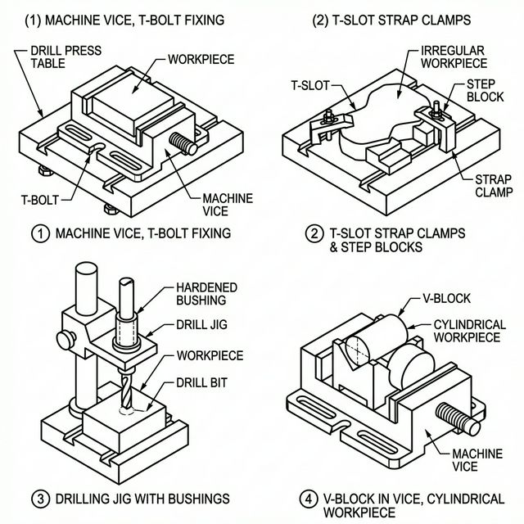
Figure 9. Different methods of fixing and clamping workpieces on a drilling machine.
1. Machine vice bolted to table via T-slots
2. T-slot strap clamps with step blocks
3. Drilling jig with hardened bushings
4. V-block for cylindrical workpieces

Tools and Mounting
The cutting tools used on drilling machines are multi-point rotary tools, as opposed to the single-point tools used on a lathe. The most common types include:
- Twist drill — the standard drilling tool, a cylindrical body with two helical flutes that create the cutting edges (lips) at the tip and provide channels for chip evacuation. The point angle is typically 118° for general-purpose drilling in steel. Twist drills are available with cylindrical shanks (smaller diameters, held in a drill chuck) or tapered shanks (larger diameters, inserted directly into the spindle via a Morse taper).
- Center drill — a short, stiff combination drill-and-countersink used to create a starting point (center hole) for a subsequent twist drill, preventing it from wandering off the intended position on the workpiece surface.
- Reamer — a multi-fluted cylindrical or tapered tool for finishing holes to tight dimensional tolerances. Reamers have straight or helical flutes and are designed for very light material removal (typically 0.1–0.3 mm per side).
- Counterbore — a tool with a pilot pin that guides it into an existing hole while the larger cutting diameter machines the flat-bottomed recess above.
- Countersink — a conical tool used to create chamfered entries to holes, typically at 60°, 82°, or 90°.
- Tap — a hardened, threaded tool used to cut internal threads inside a drilled hole. Taps come in sets of three (taper, second, and bottoming) for hand tapping, or as single machine taps for use with tapping attachments.
- Spade drill — a flat cutting blade inserted into a holder, used for drilling large-diameter holes more economically than solid twist drills.
Tool mounting: Cylindrical-shank tools are held in a keyed or keyless drill chuck, which is itself inserted into the spindle bore by a Morse taper arbor. Taper-shank tools are inserted directly into the spindle without a chuck. Removal of taper-shank tools is accomplished using a drift key (wedge) inserted through a slot in the spindle. Quick-change toolholders are available for production environments to minimize tool changeover time.
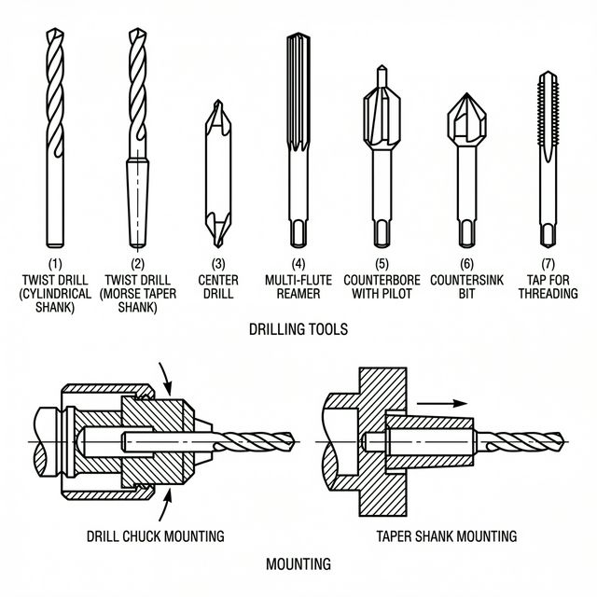
Figure 10. The most important tools used on a drilling machine and their mounting methods.
1. Twist drill (cylindrical shank) in drill chuck
2. Twist drill (taper shank) directly in spindle
3. Center drill
4. Reamer
5. Counterbore with pilot
6. Countersink
7. Tap

Special Equipment and Drilling Machine Types
Standard column drilling machines can be enhanced with various accessories to increase their capabilities. A cross-slide table (compound table) can be mounted on the drill press table to allow the workpiece to be moved precisely in the X and Y directions, transforming the drill press into a coordinate drilling machine. Tapping attachments with automatic spindle reversal are used for efficient thread-cutting operations. Coolant systems deliver cutting fluid to the drill point to reduce heat, extend tool life, and improve surface finish and chip evacuation.
Several specialized types of drilling machines exist for different industrial applications:
- Radial drilling machine — designed for large, heavy workpieces that are difficult to move. The machine features a radial arm mounted on a vertical column. The arm can swing horizontally around the column, and the spindle head can slide along the arm. This allows the drill to be positioned over any point on the workpiece without moving the part, making it ideal for machining large castings, frames, and structural members.
- Gang drilling machine — consists of multiple drilling spindles mounted in a row on a single long table. Each spindle can hold a different tool (e.g., center drill, twist drill, reamer), and the workpiece is moved sequentially from one spindle to the next, improving efficiency for multi-operation hole processing.
- Multi-spindle drilling machine — features a special multi-spindle head with many drill spindles driven from a single power source through a system of gears. All spindles operate simultaneously, drilling many holes at once in a single stroke. The positions of the spindles are adjustable to match the hole pattern required. Essential in mass production for minimizing cycle time.
- Deep-hole drilling machine — specialized for drilling holes with a very high length-to-diameter ratio (typically greater than 10:1). Uses gun drills or BTA (Boring and Trepanning Association) drills with internal coolant supply through the drill body to evacuate chips from deep holes. Applications include gun barrels, hydraulic cylinders, and oil exploration equipment.
- CNC drilling machine — a computer numerically controlled machine that automates positioning and drilling. The table or spindle moves automatically to programmed coordinates, enabling high precision and repeatability. Widely used in PCB (printed circuit board) manufacturing and aerospace applications.
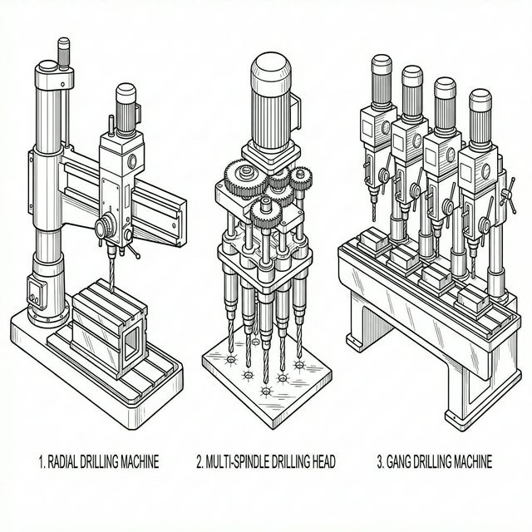
Figure 11. Special types of drilling machines: radial drilling machine, multi-spindle head, and gang drill.

B. Milling Machines

Structure and Construction
Milling machines are robust, versatile machine tools designed for heavy material removal and the generation of complex shapes. The most common configuration is the knee-and-column type, built around a massive column made of cast iron that houses the spindle drive train (motor, gearbox, and spindle). The column is the main structural backbone of the machine and provides rigidity against cutting forces.
The vertical knee slides along the front face of the column on precision guideways and can be raised or lowered (Z-axis) to adjust the vertical position of the workpiece relative to the cutter. On top of the knee sits the saddle, which provides transverse (Y-axis, in-out) motion. On top of the saddle is the work table, which provides longitudinal (X-axis, left-right) motion. Together, these three degrees of freedom allow the workpiece to be positioned precisely relative to the rotating cutter in three-dimensional space.
Two principal orientations of milling machines exist:
- Horizontal milling machine — the spindle axis is oriented horizontally. An overarm extends from the top of the column to support the outer end of the arbor (a long shaft that holds the cutter). The arbor is supported by one or more arbor supports (yoke or bearing brackets) hanging from the overarm, which resist the cutting forces and prevent arbor deflection. This configuration is best suited for slab milling and gang milling operations.
- Vertical milling machine — the spindle axis is oriented perpendicular (vertical) to the table surface. The cutter is mounted directly on the spindle nose using collets, chucks, or shell mill adapters. Some vertical milling machines have a swiveling head that allows the spindle to be tilted at an angle for angular milling operations. This type is the most versatile and widely used configuration in general workshop practice.
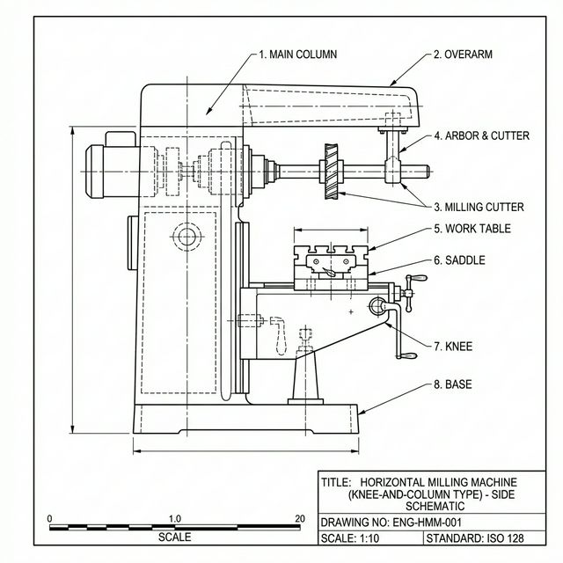
Figure 12. Structure of a horizontal milling machine (knee-and-column type).
1. Column (housing motor and gearbox)
2. Overarm
3. Arbor with cutter and arbor support
4. Work table (with T-slots)
5. Saddle
6. Knee
7. Base

Kinematics and Movements
In milling, the main cutting movement is the rotation of the cutting tool, driven by the spindle. The feed movement is performed by the workpiece, which is clamped to the table and moved linearly relative to the rotating cutter. This feed can be in the X direction (longitudinal, along the table), the Y direction (transverse, across the saddle), or the Z direction (vertical, by raising or lowering the knee). This clear separation of rotation (tool) and translation (workpiece) is what distinguishes milling from drilling, where the tool performs both motions.
There are two fundamental modes of milling based on the relationship between the direction of cutter rotation and the direction of workpiece feed:
- Up-milling (conventional milling) — the cutter rotation opposes the feed direction at the point of contact. The chip starts thin and grows thicker as the tooth progresses through its arc. This mode tends to lift the workpiece from the table, requiring robust clamping. It is gentler on the feed mechanism and is preferred when there is backlash in the feed screws.
- Down-milling (climb milling) — the cutter rotation is in the same direction as the feed at the point of contact. The chip starts thick and becomes thinner. This provides a better surface finish, generates less heat at the cutting edge, and the cutting force pushes the workpiece down into the table. However, it requires a machine with backlash-free feed screws (ball screws) to prevent the cutter from pulling the workpiece into it uncontrollably.
The cutting speed (V_{c}) in milling is determined by the cutter diameter and spindle RPM: V_{c} = (π × d × n) / 1000. The feed rate is typically expressed as feed per tooth (f_{z}), which is the amount of material each cutting edge removes per revolution. The table feed rate (V_{f}) equals: V_{f} = f_{z} × z × n, where z is the number of teeth on the cutter and n is the spindle speed in RPM.

Shaped Surfaces and Involved Elements
Milling machines are among the most versatile machine tools, capable of producing a wide variety of surface geometries:
- Flat horizontal surfaces (planes) — produced by face milling (using a face mill on a vertical machine) or by slab milling (using a cylindrical cutter on a horizontal machine). This is the most basic milling operation and is used to create reference surfaces and achieve flatness.
- Flat vertical surfaces (shoulders and steps) — created by side milling or end milling. The tool cuts on its periphery and/or on its end face to produce a step or shoulder on the workpiece. Multiple passes can create pockets and recesses.
- Slots and grooves — produced using slot drills, end mills, or side-and-face cutters. Common applications include T-slots (for machine tables, using a special T-slot cutter), dovetail slots (for slideway connections, using a dovetail cutter), and keyways (for shaft-to-hub connections).
- Angular surfaces and chamfers — created using single-angle or double-angle cutters, or by tilting the spindle head on a vertical milling machine.
- Complex 2D and 3D contours — achieved by coordinating the simultaneous movement of the table in multiple axes. Profiles such as cam surfaces, die cavities, and mold shapes can be machined. This capability is greatly enhanced by CNC (Computer Numerical Control), which can interpolate curved paths from programmed coordinates.
- Gear teeth — spur, bevel, and helical gear teeth can be generated on a milling machine using specially shaped involute gear cutters and a dividing head (indexing head) to rotate the workpiece by the correct angle between each pass. On a universal milling machine, helical gears can be cut using change gears linked to the table feed.
In all of these operations, the spindle rotates the cutter and the table, saddle, and knee provide the three-axis positioning of the workpiece. The choice of cutter type, feed direction, and axis of motion determines the surface geometry that is produced.

Fixing and Clamping Methods
Because milling generates significant cutting forces — including tangential, radial, and axial components — the workpiece must be clamped very securely to the table. The following methods are commonly used:
- Machine vice (milling vice) — the standard clamping method for small to medium-sized workpieces. Milling vices are heavier and more rigid than drilling vices, with wide jaws and a solid construction designed to resist the high lateral cutting forces. The vice is bolted to the table through T-slots and can be aligned precisely using a dial indicator against the fixed jaw. Swivel-base vices allow the workpiece to be rotated to a specific angle for angular milling.
- T-slot clamps, bolts, and step blocks — for large, irregular, or heavy workpieces that do not fit in a vice. Strap clamps, step blocks, jack screws, and T-bolts secure the part directly to the table surface. This method provides flexible and very rigid clamping for virtually any shape of workpiece.
- Dividing head (indexing head) — a precision rotary device that holds and positions the workpiece for operations requiring accurate angular rotation, such as milling gear teeth, hexagonal forms, splines, or equally spaced slots. The dividing head typically uses a worm gear mechanism with a 40:1 ratio, meaning 40 turns of the handle rotate the workpiece by one full revolution. Index plates with multiple hole circles allow for precise fractional turns (e.g., to divide a circle into any number of equal parts).
- Rotary table — a precision circular table that can be rotated continuously or indexed to specific angles. Used for machining circular features such as arcs, bolt-hole circles, and curved slots. When combined with CNC control, the rotary table effectively adds a fourth axis to the machine.
- Fixtures — special-purpose clamping devices designed for specific parts in batch or mass production. Fixtures locate the workpiece accurately and clamp it quickly, reducing setup time and ensuring repeatability. They may incorporate toggle clamps, hydraulic clamps, or pneumatic actuators for rapid operation.
- Magnetic chucks — used for clamping flat ferromagnetic workpieces. An electromagnetic or permanent magnetic chuck holds the part by magnetic attraction, eliminating the need for mechanical clamps. Useful for surface grinding and light milling operations where the cutting forces are relatively small.
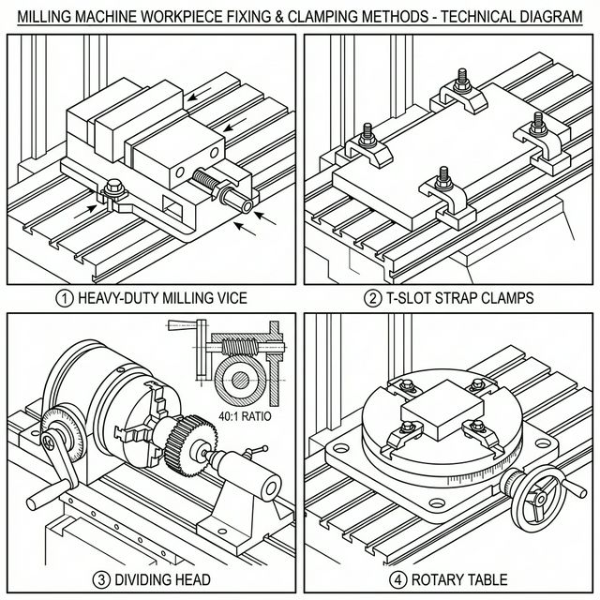
Figure 13. Different methods of fixing and clamping workpieces on a milling machine.
1. Heavy-duty milling vice bolted to table via T-slots
2. T-slot clamps with step blocks
3. Dividing head (indexing head) with workpiece
4. Rotary table

Tools and Mounting
Milling machines use multi-point rotary cutting tools, as opposed to the single-point tools used on lathes. The wide variety of cutters available is one of the primary reasons for the milling machine's versatility:
- Slab (cylindrical) mill — a plain cylindrical cutter with helical teeth on its periphery only. Mounted on a horizontal arbor for machining wide, flat surfaces (slab milling or peripheral milling). The helical teeth ensure a gradual engagement with the workpiece, reducing shock and vibration.
- Side-and-face cutter — a disc-shaped cutter with teeth on both the periphery and the side faces. Used for milling slots, shoulders, and steps. When two or more are ganged together on an arbor, they can machine multiple surfaces simultaneously (straddle milling or gang milling).
- End mill — a cylindrical cutter with cutting edges on both the end face and the periphery. End mills are the most widely used tools on vertical milling machines. They can perform plunge cutting (like a drill), peripheral cutting (along a contour), and face cutting. Available in 2-flute (for plunging/slotting), 3-flute, and 4-flute (for better finish) configurations in HSS, solid carbide, or cobalt.
- Face mill — a large-diameter cutter with multiple replaceable carbide inserts mounted on its face. Used on vertical milling machines for rapid material removal and finishing of large flat surfaces. The inserts can be indexed (rotated to a fresh cutting edge) or replaced without removing the cutter body from the spindle.
- Slot drill — similar to an end mill but typically has only two flutes and is center-cutting, designed specifically for plunge cutting and slot machining. The center-cutting design allows it to drill straight down before milling laterally.
- Form cutters — specially shaped cutters for producing specific profiles, such as concave, convex, gear-tooth involute, corner-rounding, or thread-milling cutters. The shape of the cutter is the inverse (negative) of the desired profile on the workpiece.
- Fly cutter — a single-point tool mounted in a rotating body. Despite having only one cutting edge, it can produce excellent surface finishes on large flat areas at very low cost.
Tool mounting depends on the machine type:
- Horizontal machine — cutters are mounted on a long cylindrical arbor that passes through the spindle. Spacer collars are used to position the cutter at the correct location along the arbor. The arbor is supported at its outer end by the arbor support bracket hanging from the overarm.
- Vertical machine — tools are held in the spindle using collets (R8, ER, or other systems), drill chucks, shell mill adapters, or directly via a Morse taper. Quick-change toolholding systems are common in CNC milling for minimizing tool changeover time. Modern CNC machining centers use standardized toolholders (e.g., CAT, BT, HSK tapers) that interface with automatic tool changers.
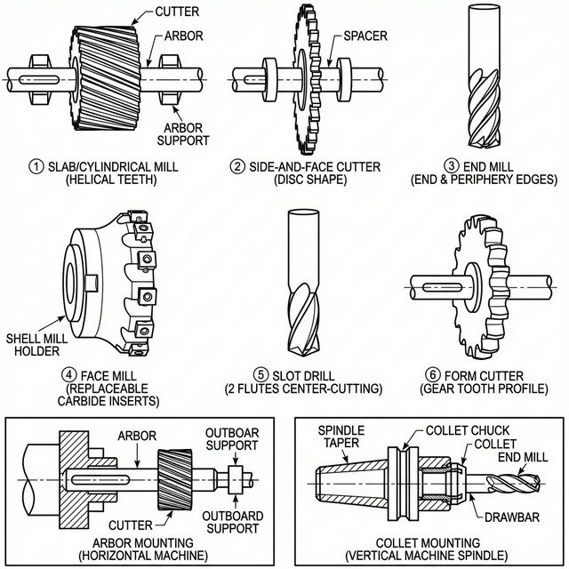
Figure 14. The most important milling cutters and their mounting methods.
1. Slab mill on horizontal arbor
2. Side-and-face cutter
3. End mill in collet on vertical spindle
4. Face mill with carbide inserts
5. Slot drill
6. Form cutter (gear-tooth profile)

Special Equipment and Milling Machine Types
Standard knee-and-column milling machines can be equipped with a range of accessories to extend their capabilities:
- Dividing head (indexing head) — used for equally spacing cuts around a circumference, such as when milling gear teeth, splines, or hexagonal forms. It is one of the most important milling machine accessories.
- Slotting attachment — converts the rotary output of the spindle into a reciprocating linear motion, allowing the milling machine to perform slotting operations similar to a shaper. Useful for machining internal keyways and splines.
- Vertical milling attachment — mounted on a horizontal milling machine to convert it for vertical milling operations, adding versatility without requiring a separate machine.
- Rack milling attachment — a specialized accessory for milling gear racks (straight teeth) that converts rotary motion into the linear indexing needed between successive tooth cuts.
Several important specialized milling machine variants exist:
- Universal milling machine — essentially a horizontal milling machine with the addition of a table swivel feature that allows the table to be rotated in the horizontal plane. This is essential for helical milling operations, such as cutting helical gears, twist drills, and milling cutters. A dividing head connected to the table lead screw via change gears provides the coordinated helical feed.
- Bed-type milling machine — the table is mounted on a fixed bed and can only move longitudinally (X-axis). The spindle head moves vertically (Z-axis) on the column. This design provides much greater rigidity than the knee-and-column type, making it suitable for heavy-duty milling of large castings and structural parts.
- Planer-type milling machine (plano-miller) — a very large machine with multiple spindle heads mounted on cross-rails above a long table. Designed for machining very large workpieces such as machine tool beds, bridge components, and heavy structural frames. Multiple surfaces can be machined simultaneously.
- CNC milling machine / machining center — a computer-controlled milling machine that automates all axis movements, spindle speeds, and feed rates. Modern CNC machining centers feature automatic tool changers (ATC) with tool magazines holding 20–100+ tools, allowing multiple operations (drilling, tapping, milling, boring) in a single setup without manual intervention. Five-axis CNC machines add two rotary axes (typically A and B or B and C), enabling the machining of extremely complex 3D geometries such as turbine blades, impellers, and aerospace structural components.
- Copy (tracer) milling machine — uses a stylus that follows a template or model while the cutter replicates the shape on the workpiece. This was an important method for producing complex 3D shapes (dies, molds) before CNC technology became widely available.
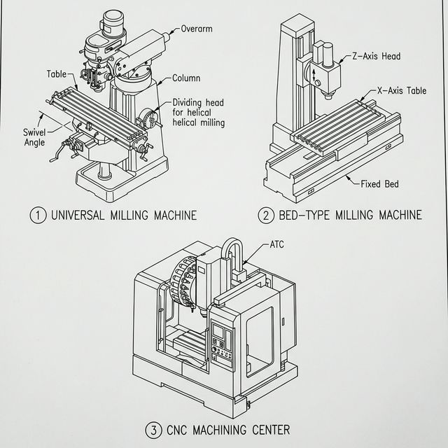
Figure 15. Special types of milling machines: universal milling machine, bed-type milling machine, and CNC machining center.

Conclusions
The laboratory survey highlighted the fundamental differences in kinematics between the three primary classes of machine tools studied. The lathe is unique in that the workpiece provides the main rotary motion while the tool provides the feed, making it the superior choice for creating radially symmetric parts (surfaces of revolution). In contrast, both drilling and milling machines rely on the tool for the main rotary cutting motion, but differ fundamentally in how the feed is achieved: in drilling, the tool itself performs the axial feed into the stationary workpiece, whereas in milling, the workpiece (via the table) provides a multi-axial feed relative to the rotating cutter.
The survey also revealed important differences in workpiece clamping strategies dictated by the kinematic requirements and cutting forces of each machine type. On lathes, workpieces are clamped in chucks (three-jaw, four-jaw), collets, faceplates, or between centers to allow high-speed rotation. On drilling machines, vices, T-clamps, V-blocks, and specialized drilling jigs hold the workpiece stationary on the table while resisting the torque and thrust of the drill. On milling machines, the higher and more complex cutting forces necessitate more robust clamping — heavy-duty milling vices, T-slot clamping sets, and specialized accessories such as dividing heads and rotary tables, which also expand the geometric capabilities of the machine beyond simple linear surfaces.
Furthermore, the tooling differs significantly across the three machine types. Lathes use single-point cutting tools mounted on the tool post or in the tailstock. Drills use multi-point axial tools (twist drills, reamers, taps, counterbores) held in the spindle chuck or taper. Milling machines employ the widest variety of multi-point rotary cutters (end mills, face mills, slab mills, side-and-face cutters, form cutters), each mounted according to the machine's orientation — on horizontal arbors or in vertical collets. The specialized variants of each machine — turret lathes, radial drilling machines, CNC machining centers — demonstrate how the basic kinematic principles are adapted and expanded to meet industrial demands for higher speed, greater precision, increased flexibility, and heavy-duty machining capability.
The progressive evolution from manual machines to CNC-controlled systems represents the most significant trend in modern manufacturing. CNC technology combines the kinematic principles of all three machine types into single multi-function machining centers, reducing the number of setups, improving accuracy, and dramatically increasing productivity.

